GomSpace TSP solar panel definition

# Table of Contents

1 Table of Contents 2

2 Introduction 2

2.1 Configurable Solar Panel Requirement 2

2.2 Electrical requirements: 3

2.3 Input from project lead and mechanics 3

2.4 Mechanical details 4

2.5 Electrical details 4

2.5.1 Basis for the design & Considerations for changes 4

2.5.2 Limits: Serial and parallel configuration 5

2.5.3 Thermal considerations 6

3 Possible configurations. 6

4 Appendix, Solar panels 7

4.1 Azur Space 7

4.2 Cesi Solar panels 7

# Introduction

This document describes the considerations for definition of TSP panels with regards to P60 and P80 configured satellite systems. Most of the document is trying to figure out the possibilities gives by the P60 and P80 systems and the possibilities this TSP panels are providing.

The document is only describing the 6U panels. (3 panels/wing)

During the document definitions for both Cesi and Azur space solar cells are used. They have some similarities and some differences.

## Configurable Solar Panel Requirement

* The overall requirements are to design each panel with 15 solar cells.
* These cells shall be connected in 2 max 3 strings.
* The designed panels may be able to be used in all positions 1 to 3 (4).
* It is needed to be able to measure the temperature on minimum 1 panel/wing.
* It is highly wanted to be able to use either Cesi cells or Azur cells on the same design (not combined but either or)
* Temperature range -75 to +105⁰C

## Electrical requirements:

* Blocking Diode (to be Considered), needed if more strings in parallel on same ACU channel.
* The design shall allow for solar array configuration with 1-4 panels.
* It shall be possible to adjust mechanics to have more than >>1k-ohm resistance between the SA and and the space craft chassis.
* The PCB shall be designed to accommodate both AZUR space and the CESI solar cell.
* The TSP shall be able to deliver in excess of 35W when fully illuminated (one wing) (3x power gain over DSP)
* Avoid hardware options (such options significantly hurt the business case because of cost and complexity of handling order/customer)
* The TSP shall fit in a GomSpace 6U or 12U platform with no required modifications to other products
* The design should be compatible with both the P60/BPX power system as well as the P80/BP8 power components.
* The panel pcb should accommodate a temperature sensor.
* PCB should be configurable to accommodate 2 or 3 strings of solar cells.
* The panel PCB shall be designed to have a minimum magnetic dipole moment which does not exceed 10mA*m^2 when illuminated by TOA sun light intensity
* On three-string panels, it is preferred if two of the strings can be made parallel on the pcb.
* The TSP shall be compatible with power interfaces to NanoPower P80 and P60 products and data/control interfaces to NanoMind A3200 product (Sales)
* If possible, detection of successful deploy should be added.
* A temperature variation of approx [-75deg C; 90 deg C] shall be considered in the design of the solar array.
* A final test should be defined to ensure the fully assembled wing works from an electrical point of view.
* Need a method to detect the panels is not folded out.
* Consider 2 bypass diodes on each Solar Cells, relevant for deep sky panels.

## Input from project lead and mechanics

Temperature to be expected, solar panels are exposed to extreme temperature cycling during flight:

In sun: +80 - +90 ⁰C. In Eclipse: -75 ⁰C. Pearls was tested with 22K temperature cycles, cycling from -75 to +105 ⁰C. Other components on the solar panel PCB should be able to operate in the same temperature range, as the thermal inertia in the solar panel PCB is relatively small.

The suggestion is to replace the traditional electric connection of solar cells, from existing soldering to Welding. Use of welding should be easier to control in term of heat, but it requires

* Design for welding; no components at the backside of the PCB (in the area where welding shall be supported)
* Other PCB surface treatment (e.g. ENEPIG, compared to today=ENIG)

PCB type:

It is suggested to use Arlon NT, as this has the lowest variation over temperature, compared to Arlon 85. To investigate how are the CU traces stressed when used with Arlon NT in the extreme solar panel temp range.

Connector/Cable type:

AXON connector like Pearls (TSP-8UL), cables will then be manufactured by “amgab.se”.

Earlier we used Pico-lock

RELEASE MECHANISM:

Release of the solar panels consider reuse of the concept from “Reflect array”. This is an interstate that only provide burning and release detection feature no further functionality is supported by this design. Check the AR6 board, and

GitHub\hw_family_nanopower\TSP-8UL-Pack\Panel-Release-Mechanism\Release_Main

Ensure redundancy for the release PCB design.   
Today there are 2 uC and each of the uC controls 2 release resistors, 1 in each side of the release PCB. Additionally, the burn power goes to a connector. Check how the burning is done, which wire runs across which resistor? To where (from the connector) does the burn power go?

## Mechanical details

The mechanical design is made in a way where the same PCB can be used on all places in the solar array. This is decided to be made it with as much reuse as possible. In principle all panels in a wing is equal, no matter if it is placed nearest the structure or any other places.

The requirement is that the constructed panel are made by combining 3 panels, repeated on both sides of the structure. These “wings” are connected mechanically to the structure by a gearbox, the gearbox makes it possible to turn the panel for maximum solar contact.

Number of solar cells pr. panel is due of mechanics limited to 15 cells total per panel. These cells are expected to be arranged into either 3 strings or only 2 strings. This will be described in the next pages.

Request are 1 to 3 (4) panels pr. wing.

## Electrical details

### Basis for the design & Considerations for changes

The chosen solar cells are manufactured by Cesi or Azur.

Electric key data for these cells is:

Azur space Cesi .

Open circuit voltage: 2.69V 2.60V

Closed circuit voltage 2.40V 2.26V

Current (max) 504mA 510mA (Up to)

These key data will be used in the following considerations / calculations.

### Limits: Serial and parallel configuration

The connection to the battery is done via an electric circuit, this circuit has some limitations both with regards to input voltage and maximum current.

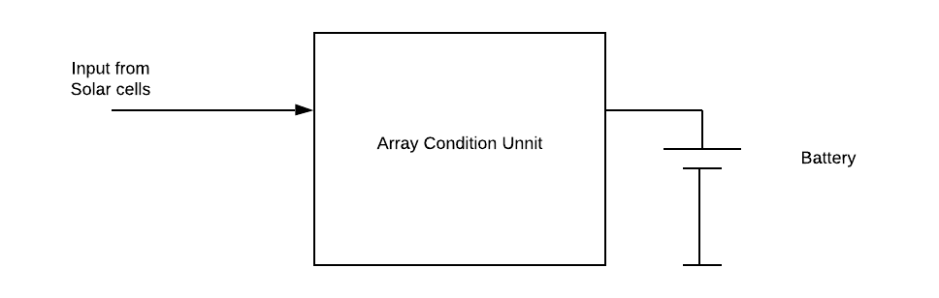

The circuit used to connect the solar panels to the batteries are called Array Condition Unit; ACU, this unit are conditioning the delivered voltage and current from solar panels to battery levels. The ACU has 2 demands; the delivered voltage in open circuit may never be higher than the nominal battery voltage. In connected it may never be higher than Vbat or 25V as absolute max.

P60 are as follows:

* + 6 Input channels
    - Vin maximum is equal to Vbat.
    - Iin = 2A max (pr. channel)

P80 are as follows:

* + 12 Input channels
    - Vin maximum is equal to Vbat.
    - Iin = 1.2A max (pr. channel)

With these numbers in mind it is possible to determine the possible configurations for connection of the solar array to the ACU unit. Open circuit voltage, and maximum loaded current is used.

Calculations to identify the max. number of serial and parallel solar cell per ACU channel. When cells are connected in serial the voltage is raising with the number of cells -> this may be considered when maximum numbers are calculated – When cells are connected in parallel the current is raising with the numbers off cells -> this may be considered when numbers are calculated.

Max input in serial: (Vbat or 25V / Vopen circuit) = max; 25V is maximum input for ACU circuit.

Max input in parallel: (Iin / Imax) = max (2A for P60 and 1.2A for P80; for each input on the ACU)

Battery voltage is calculated with 4.2V pr. cell. Gives the following:

16.8V battery Azur Cesi cells

OCV CCV OCV CCV

Numbers of cells in serial 6,25 -> **6** **7** 6,45 -> **6 7**

Numbers of cells in parallel (P60) 3,96 -> **3** **3** 3,92 -> **3** **3**

Numbers of cells in parallel (P80) 2,38 -> **2** **2** 2,35 -> **2** **2**

33.6V battery _____ .

OCV CVV OCV CVV

Numbers of cells in serial 12,42 -> **12 10** 12,92 -> **12 11**

Numbers of cells in parallel (P60) 3,96 -> **3** 3,92 -> **3**

Numbers of cells in parallel (P80) 2,38 -> **2** 2,35 -> **2**

The maximum current allowed into the ACU is maximum for the circuit, maximum for the components is higher due to the derating factor used in Gomspace designs, if this factor is adjusted it might be possible to get more cells in parallel; especial P60 is “close”.

# Possible configurations.

As it might be clear from the above description / calculations, the problem is relative complex. The ACU in the satellite provide some possibilities but also some limitations, in the same way are the solar panels providing some possibilities and some limitations, unfortunately it is not possible to do adjustments, only combinations in numbers of solar cells can be used as adjustments.

Requirements from the project is demanding 15 cells pr. panel so here we again meet some limitations for adjustments.

In this design we plan to design for possible 3 different configurations; 15 cells in 3*5 cells: 3 strings. 15 cells in one string with 7 cells and one with 8 cells, this can be configured by HW.

It will give 3 different voltages: (open circuit)

5 Solar cells 13.45V 500mA for Azur cells

13.00V 510mA for Cesi cells

7 Solar cells 18.83V 500mA for Azur cells

18.20V 510mA for Cesi cells

8 Solar cells 21.52V 500mA for Azur cells

20.80V 510mA for Cesi cells

(7 and 8 solar cells in serial cannot be used with a battery voltage on 16.8V as they deliver more than 16.8V pr. string.)

It will give 3 different voltages: (closed circuit)

5 cells in serial gives with Azur space cells 2.4V*5 =12V – 500mA pr. string

5 cells in serial gives with Cesi cells 2.26V*5 =11.3V – 510mA pr. string

7 cells in serial gives with Azur space cells 2.4V*7 = 16.8V – 500mA pr. string

7 cells in serial gives with Cesi cells 2.26V*7 =15.82V – 510mA pr. string

8 cells in serial gives with Azur space cells 2.4V*8 =19.2V – 500mA pr. string

8 cells in serial gives with Cesi cells 2.26V*8 =18.08V – 510mA pr. string

With a battery pack on 16.8V it is possible to use the solar panel in the configuration with 3*5 cells pr. panel only, this is limited by the max allowed voltage into the ACU.

6 panels with all in all 90 solar cells will require the strings to be combined into groups.

For connection to P60 we can Accept 12V 2A pr. input, 6 input is available. This will require 9 inputs -> we need 2 ACU to be capable to charge the batteries with the full amount of absorbed energy from solar panels.

For connection to P80 we can deliver 12V 1A pr. input, 12 input is available. This will require 18 inputs -> we need 2 ACU to be capable to charge the batteries with the full amount of absorbed energy from solar panels.

### Possible configurations.

Panels configured in 3 strings pr. panel and connected directly to the structure will give this situation:

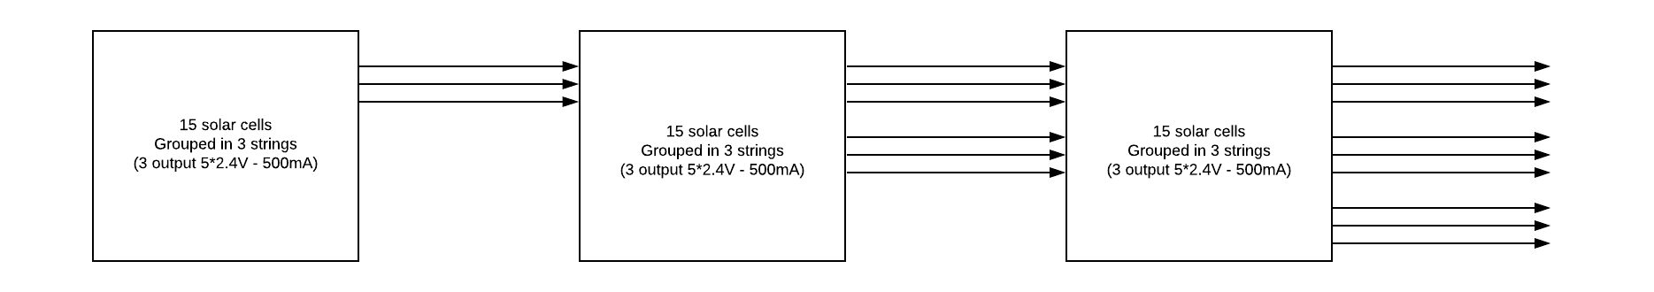

3 panels with total 45 solar cells – 9 strings providing 12V 500mA (Azur cells)

If we on the panels combine some strings, we can reduce number of wires to the structure:

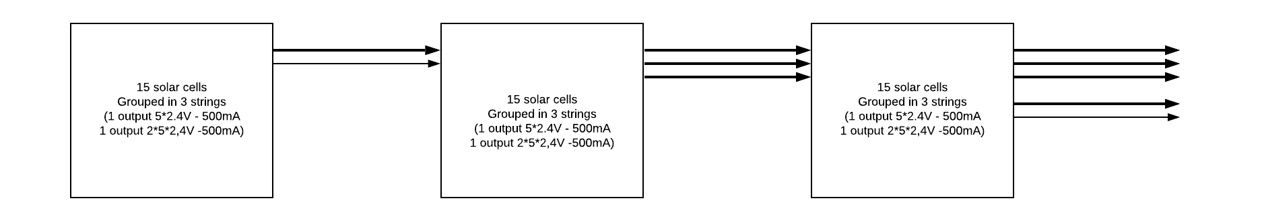

3 panels with total 45 solar cells – 5 strings; 4 12V – 1A and one 12V 500mA (Azur cells)

These 2 configurations can be used in combination with P60 or P80 and 16V or 32 V battery package.

Panels configured in 2 strings pr. panel and connected directly to the structure will give this situation:

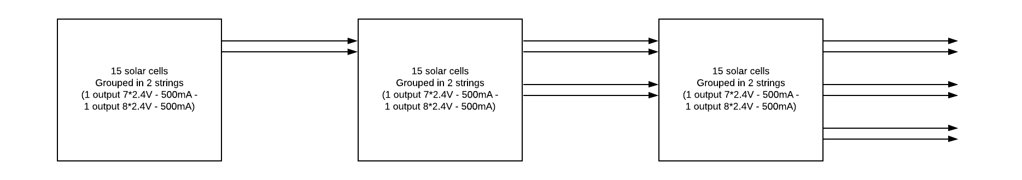

3 panels with total 45 solar cells – 6 strings providing 16,8V 500mA and 19,2V 500mA (Azur cells)

This configuration can only be used with P60 or P80 and 32V battery package. (Input voltage is over 16,8V).

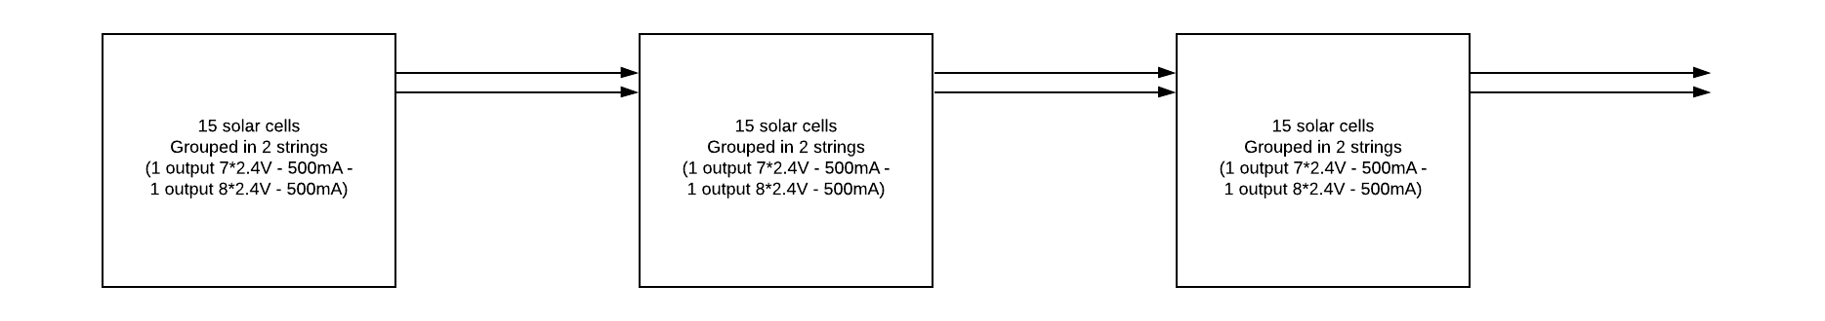

3 panels with total 45 solar cells – 2 strings providing 16,8V 1,5A and 19,2V 1,5A (Azur cells)

This configuration can only be used with P60 and 32V battery package. (P80 only allow 1A and voltage is over 16.8V)

### Thermal considerations

When connecting solar arrays to input on P60 / P80 it is crucial to consider the thermal problems also. The ACU is not 100% effective, it is a good design, but the loss must be considered when configuring the system. Expect the loss to be around 7% of the applied energy.

# Appendix, Solar panels

There are 2 types of solar panels on stock, Azur and Cesi. Electrical connection is different between Azur and Cesi solar panels (Anode and Catode is placed different) It might be possible to design a footprint for PCB covering both Azur and Cesi cell types even the cathode and Anode is placed different. If this is possible and are used it will make the designed solar panel more flexible for future use. It is only a matter of doing the PCB so both cells are possible to mount – can be handles as a mounting variant in Altium /IFS.

## Azur Space

Azur solar panel P/N: 3G30A W and W/O diode

Most effective and most costly.

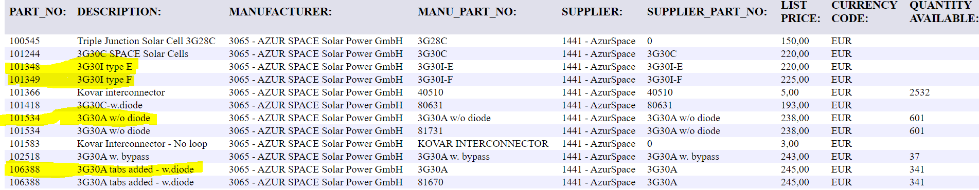

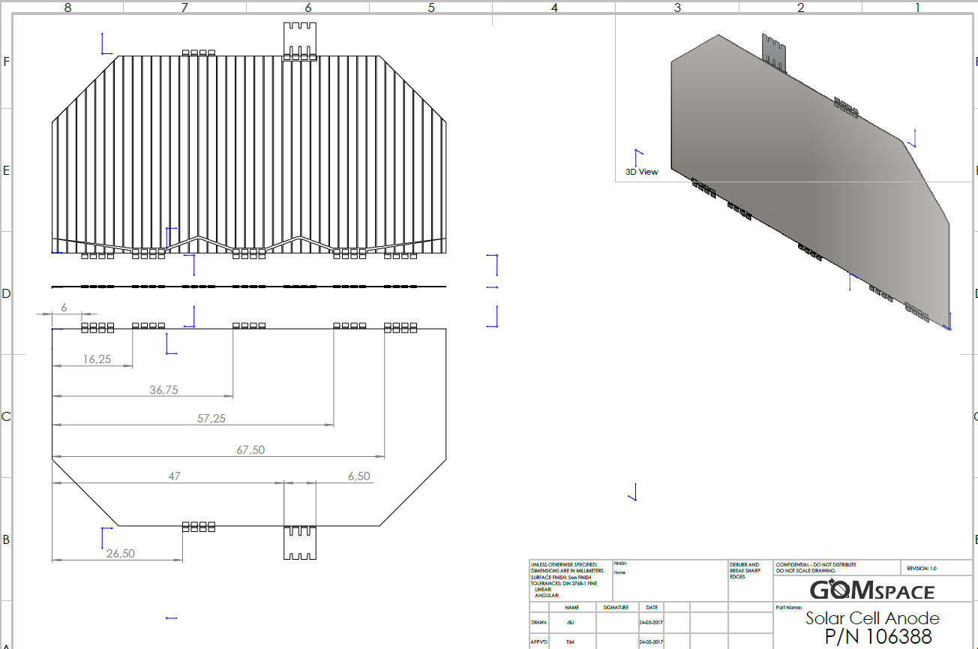

## Cesi Solar panels

CESI solar panel P/N: CTJ/SCA-8040/GOM

Less effective compared to Azur, but “Cheaper” than Azur.

Very high quantity on stock (3523 pcs.)



